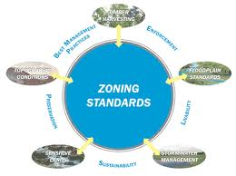
GOSHEN TOWNSHIP ZONING COMMISSION
Zoning commission meeting held the first Tuesday of each month at 7:00 P.M. in the Goshen Township Government Center meeting hall, 6757 Goshen Road, one-half block south of SR 28 in Goshen.

Term of Office
Elben Miller, Chair 2010-2014
Steve Holland, Co-Chair 2011-2015
Bob Seyfried 2008-2012
Tom Risk 2009-2013
Lee Lewis 2010-2014
Alternate Gale Perkins 2011

All full member terms are for five year; alternate member terms are for one year. Each of these terms begin January 1st and ends on December 31st.

Staff support provided by our Community & Economic Development Department.

